Application Building

Execute And Test Your

Model

|  |  |
| --- | --- |
| Date | 31 October 2022 |
| Team ID | PNT2022TMID34307 |
| Project Name | Car Resale Value Prediction |

# Home Page



# Data Entry Page

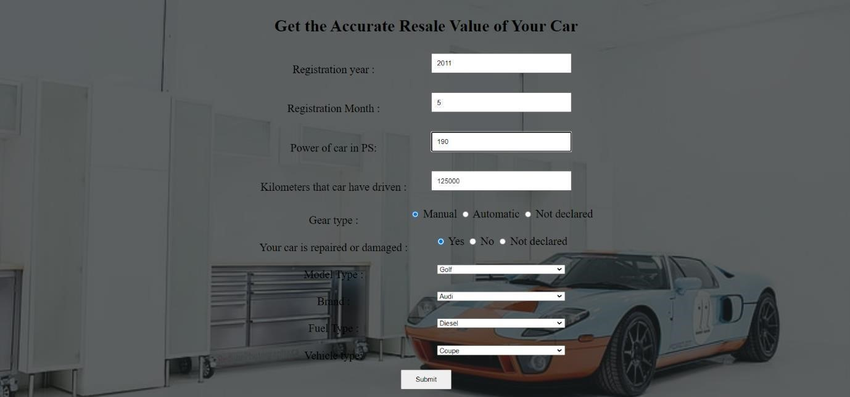

# Car Resale Value Display Page

